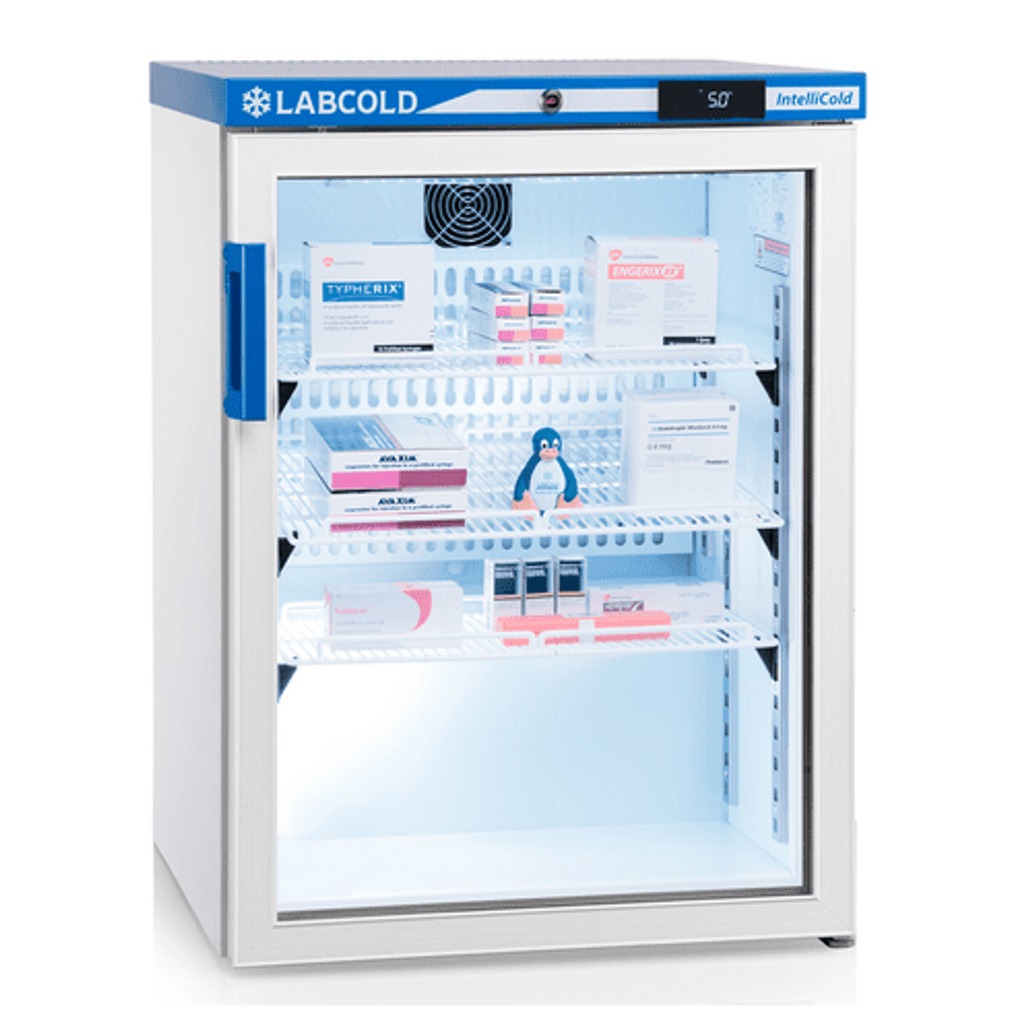
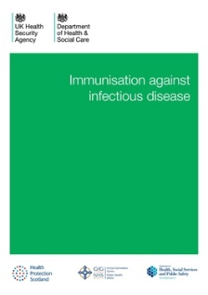
Vaccine Fridge Audit
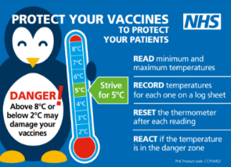

The Medicine Optimisation Team has developed a Vaccine Fridge Audit Tool. This will allow Practices to
self-audit against CQC Standards and The Green Book guidance. It is a CQC requirement that all staff handling vaccines, from receipt to administration should be trained to follow policies to ensure ‘cold chain compliance.’
All staff involved in immunisation should follow these policies to store and manage vaccines properly.
- Vaccines may lose their effectiveness if they become too hot or too cold at any time.
- Vaccines naturally biodegrade over time. Being stored outside the recommended temperature range, including during transport, may speed up loss of potency. This cannot be reversed.
- A vaccine may then fail to create the desired immune response and give protection.
- Storing and transporting vaccines inappropriately causes waste and unnecessary cost.
During a CQC inspection, inspectors will expect to see evidence of maintenance of the cold chain. Providers will be asked to show how they follow the PHE recommendations. This includes receipt of vaccines into the practice until administration to the patient. Inspectors may also ask to see evidence of the log of fridge temperatures, maintenance checks and a policy for what to do if a temperature breach occurs. Inspectors may also check the fridge to see if the vaccines are being stored appropriately.

The audit is available in both Word and Excel format.
If you have any queries, please contact your Medicines Optimisation Team Technician.

To contact the Medicines Optimisation Team please phone 01772 214302
If you have any suggestions for future topics to cover in our prescribing tips please contact Nicola.schaffel@nhs.net
All content accurate and correct on the date of issue of this tip.

